Cross-Body Site Microbial Interactions Influence the Human Plasma Metabolome

Jingxiang Zhang^{1,2}, Chao Jiang³, Xin Zhou⁴, Peng Gao⁵, Sunny Wong¹, Michael Snyder⁶, Xiaotao Shen^{1,2,7*}
- Lee Kong Chian School of Medicine, Nanyang Technological University, Singapore, Singapore.
- School of Chemistry, Chemical Engineering and Biotechnology, Nanyang Technological University, Singapore, Singapore.
- Life Sciences Institute, Zhejiang University, Hangzhou, Zhejiang, China.
- Intelligent Medicine Institute, Fudan Microbiome Center, Fudan University Shanghai Medical College, Fudan University, Shanghai, China.
- Department of Environmental Health and Department of Molecular Metabolism, Harvard T.H. Chan School of Public Health, Boston, MA, USA.
- Department of Genetics, Stanford School of Medicine, Palo Alto, CA, USA.
- Singapore Phenome Center, Nanyang Technological University, Singapore, Singapore.

* Corresponding author: Xiaotao Shen (xiaotao.shen@ntu.edu.sg).

Abstract
The human microbiome profoundly influences host plasma metabolome and health, yet most studies have focused on the gut microbiome in isolation. Here, we provide a comprehensive analysis of how microbiomes from multiple body sites selectively and jointly influence the human plasma metabolome. Using data from three independent human cohorts (n = 435 in total), we demonstrate that microbiomes from all body sites can influence the human plasma metabolome (814 annotated metabolites). Together, these microbiomes explained 33.25% of the inter-individual variation of plasma metabolome, with the gut microbiome contributing the most (18.04%), followed by the oral (13.35%), skin (9.07%), and nasal (5.82%) microbiomes. Notably, our findings reveal that microbial composition does not necessarily predict metabolic function. For instance, despite distinct microbial composition, oral and gut microbiomes exhibit similar associations with circulating metabolites. Machine learning and mediation models uncover widespread cooperative and synergistic microbial interactions across body sites, particularly along the oral-gut axis. We found that more than half of the metabolites (61.8%) are jointly influenced by the microbiome from multiple body sites. This axis demonstrates cross-body site microbial crosstalk and sequential metabolic processing that jointly regulate circulating metabolites, including indole derivatives and carboxylic acids. This oral-gut microbiome-metabolome axis is further amplified in insulin resistance (IR), linking enhanced microbial cooperation to metabolic dysregulation. Overall, our results establish the systemic and interactive nature of microbiome-metabolome relationships, highlighting the importance of integrating spatially distributed microbial ecosystems to fully understand host metabolic regulation and diseases.

Introduction
The human microbiome, composed of trillions of microorganisms residing across diverse body sites, is increasingly recognized as one of the central regulators of host physiology and metabolism^{1–3}. Among these microbial communities, the gut microbiome has been most extensively studied, with substantial evidence linking it to circulating metabolites and systemic metabolic phenotypes such as obesity, IR, and inflammation^{4–6}. These insights, along with other studies, have established the gut microbiome as a significant contributor to host metabolic homeostasis^{7,8}. However, the human body harbors other large and ecologically distinct microbial ecosystems, such as those in the oral cavity, nasal cavity, and on the skin, that are less well characterized in terms of their contributions to host systemic metabolism.
Emerging evidence suggests that these non-gut microbiomes may also influence host physiology beyond their local environments^{9–11}. For example, oral and nasal microbiomes have been implicated in respiratory diseases and cardiovascular risk^{12,13}, and skin microbes are known to participate in immune modulation¹⁴. Despite this, the influence of microbiomes from these non-gut sites on the human plasma metabolome and their subsequent effects on human health remain poorly understood. It also remains unclear whether microbial communities from different body sites act independently or interactively to influence systemic metabolic profiles.
This gap is particularly important given the growing recognition that microbial ecosystems across the human body sites may not function in isolation^{15,16}. Anatomically connected sites, such as the oral cavity and gut, engage in microbial “crosstalk,” potentially enabling cooperative or sequential processing of dietary and host-derived substrates¹⁷. For instance, dietary tryptophan may be metabolized into indole derivatives by the oral microbiome and further transformed by the gut microbiome into circulating metabolites with immunomodulatory properties^{18,19}. While previous studies have suggested that the oral microbiome can influence gut microbial composition or function^{20,21}, the potential for coordinated microbial metabolism across body sites remains largely unproven.
To address these knowledge gaps, we conducted an integrative multi-omics study to systematically characterize how microbiomes from multiple body sites influence the human plasma metabolome. We analyzed data from three independent human cohorts, including one discovery cohort with matched microbiome data from the gut, oral cavity, nasal cavity, and skin, along with paired plasma metabolomics data^{22–24}. Two additional validation cohorts with gut and/or oral microbiome data were used to confirm key findings^{25,26}. We quantitatively assessed the individual and joint contributions of microbiomes from different body sites to circulating metabolite levels after correction for age, sex, BMI, and ethnicity using machine learning methods, including gradient boosted decision trees (GBDTs), combined with metabolite variance decomposition, cross-body site microbial interaction modeling, and mediation analysis.
We hypothesized that microbiomes from different body sites, particularly the oral and gut microbiomes, cooperatively regulate the plasma metabolome via synergistic and potentially sequential metabolic processes. Specifically, we sought to answer the following questions: (1) Which microbiomes, by body site, contribute most strongly to inter-individual variation of the plasma metabolome? (2) Do microbiomes from different body sites interact synergistically to co-regulate specific circulating metabolites? (3) Can directional microbial processing across body sites, particularly from the oral to the gut, be demonstrated via mediation modeling? (4) What are the broader biological implications of multiple body site microbial cooperation for systemic host metabolism and metabolic disease? By addressing these questions, our study uncovers novel insights into the systemic and cooperative roles of the human microbiome across multiple body sites, highlighting how host-microbiome interactions transcend individual niches to collectively shape human metabolic health. To our knowledge, this is the first comprehensive investigation to demonstrate how microbiomes from distinct body sites jointly influence the human plasma metabolome.

Results
Microbiomes from Different Body Sites Show Selective and Non-Compositional Influences on the Plasma Metabolome
To investigate the relationship between the microbiomes from multiple body sites and human plasma metabolome, we analyzed data from three independent human cohorts with varying levels of multi-omics resolution (Methods). The discovery cohort included 108 participants with matched microbiome data from four body sites, namely the gut, oral cavity, nasal cavity, and skin, along with paired plasma metabolome data^{22–24} (Fig. 1a). To our knowledge, this is the only human cohort currently available that provides integrated plasma metabolome and microbiome data from these four major body sites. Validation cohort 1 included 200 participants with gut and oral microbiome and plasma metabolome data²⁵, while validation cohort 2 included 127 participants with gut microbiome and plasma metabolome data²⁶. The demographic characteristics of the discovery cohort and validation cohort 2 are summarized in Supplementary Fig. 1a,b, and provided in Supplementary Table 1.
In the discovery cohort, 814 circulating metabolites were detected using LC-MS/MS across diverse metabolite classes (Fig. 1b). The most prevalent categories included carboxylic acids and derivatives (166, 20.39%), fatty acyls (115, 14.13%), and glycerophospholipids (64, 7.86%) (Methods and Supplementary Table 2). Notably, a subset of these metabolites, spanning multiple chemical classes, was identified as microbiota-derived, indicating their production or co-metabolism by microbiota (Methods). Although they represented a smaller fraction of total metabolites (78/814, 9.58%), these microbiota-derived metabolites were distributed across various classes including carboxylic acids (n = 15), benzene and substituted derivatives (n = 13), indoles and derivatives (n = 11), and phenolic compounds (n = 5) (Fig. 1b and Supplementary Fig. 1c). These findings are consistent with previous studies highlighting the widespread metabolic influence of microbial communities on circulating metabolites^{27,28}. With this comprehensive metabolomic landscape established, we next examined how microbiomes from different body sites relate to these circulating metabolites.
We assessed the intrinsic compositional similarity of microbiomes from multiple body sites. Non-metric multidimensional scaling (NMDS) based on microbial community profiles (relative abundance at genus level; Methods) revealed that skin and nasal microbiomes clustered closely, indicating similar overall microbial composition structures. In contrast, oral and gut microbiomes formed distinct and well-separated clusters (Fig. 1c), which are consistent with previous studies²⁹. To characterize these patterns further, we defined core microbiota at the genus level using relative abundance and prevalence thresholds (Methods). As expected, the results showed that the skin and nasal microbiome have very similar core microbiota, and are both predominantly composed of Staphylococcus, Cutibacterium, and Corynebacterium^{30,31}(Fig. 1d). In contrast, the gut microbiome was enriched for Phocaeicola, Bacteroides, and Faecalibacterium^{32,33}, while the oral microbiome was dominated by Prevotella, Neisseria, and Veillonella^{34–36}(Fig. 1d). These findings are consistent with previous studies describing the spatial compartmentalization and ecological differentiation of the human microbiome across different body sites³⁷.
Given the distinct microbial composition from different body sites, we next assessed their overall associations with the human plasma metabolome. Previous studies have demonstrated associations between gut microbiome diversity and plasma metabolome^{7,38}, but it remains unclear whether microbiomes from other body sites exhibit similar associations with the plasma metabolome. To this end, we computed Spearman correlations between microbiome alpha diversity (Shannon index) from each body site and each circulating metabolite (Methods and Supplementary Table 3). As expected, multiple known microbiota-derived metabolites, including phenylacetylglutamine (PAGln)³⁹, 5-hydroxyhexanoic acid⁴⁰, p-cresol sulfate⁴¹, and p-hydroxyphenylacetic acid⁴², showed significant positive correlations with gut microbiome alpha diversity (Fig. 1e and Supplementary Table 3; FDR-adjusted P < 0.05).
Interestingly, we also observed body site-specific patterns between the microbiome and circulating metabolites (Supplementary Table 3). For example, glycerophospholipid metabolites are positively correlated with skin microbiome alpha diversity but negatively with nasal microbiome diversity (Fig. 1e), even though the skin and nasal microbiomes have similar microbial composition (Fig. 1c,d). This result suggested that the function of the microbiome may be closely related to its ecological niche⁴³. Overall, microbiota-derived metabolites exhibited significantly stronger absolute correlations with microbiome alpha diversity across all body sites than non-microbiota-derived metabolites (mean absolute rho: 0.31 vs. 0.26; Wilcoxon test, P < 0.01; Fig. 1f). Additionally, the strength of associations with circulating metabolites varied microbiomes by body site, with gut microbiome consistently showing the strongest overall correlations with circulating metabolites, followed by oral, skin, and nasal microbiomes (Wilcoxon test, P < 0.01; Supplementary Table 3; Fig. 1g).
Lastly, we examined whether the metabolite class distributions of significantly associated metabolites differed across microbiomes from different body sites. The metabolite classes associated with oral and gut microbiome diversity were highly similar (Fig. 1h and Supplementary Fig. 1d; Chi-squared test, P > 0.05), both enriched in fatty acyls and carboxylic acid derivatives (Fig. 1h). In contrast, circulating metabolites associated with skin and nasal microbiomes showed greater heterogeneity (Fig. 1h and Supplementary Fig. 1d).
Overall, while microbiomes from different body sites exhibit clear spatial distinctions in their microbial composition (Fig. 1c,d), these microbial compositional patterns do not directly reflect their metabolic function, namely, their impact on the plasma metabolome. We found that the metabolic associations of each microbiome are highly selective and body site-specific, with skin and nasal microbiomes showing divergent correlations with key metabolite classes despite their similarity of microbial composition. These findings suggest that similar microbial communities may exert distinct metabolic effects depending on their anatomical context, highlighting the importance of integrating functional data (metabolome) to fully understand host-microbiome interactions beyond the microbiome alone.

Gut Microbiome Dominates in Influencing Plasma Metabolome Compared to Other Body Sites
Having established that microbiomes from multiple body sites are associated with the human plasma metabolome above, we next sought to quantify the extent of this influence and identify which body sites exert the most significant effects. To this end, we calculated the proportion of inter-individual variance in the plasma metabolome (814 annotated metabolites) explained by each body site microbiome (Methods). The results revealed that the microbiomes explained 33.25% of the inter-individual variation in plasma metabolome, with the gut microbiome contributing the most (18.04%), followed by the oral (13.35%), skin (9.07%), and nasal (5.82%) microbiomes (Fig. 2a). The magnitude of influence observed for the gut microbiome is consistent with a previous study reporting that gut microbial features explained approximately 12.8% of the variance in the plasma metabolome in a Dutch cohort⁸. However, few previous studies have quantified the contributions of microbiomes beyond the gut, making our findings for microbiomes from other body sites particularly novel and informative. Interestingly, we found that combining the microbiome data from four sites can significantly improve the explanatory power of metabolome variation (33.25%, Fig. 2a). To understand which specific microbial taxa drive these body site-specific contributions, we performed detailed correlation analyses between individual genera and metabolite profiles.
As expected, microbiomes from all body sites explained a greater proportion of variance in microbiota-derived metabolites than in the overall metabolites: 37.22 for all microbiome, 25.12% for the gut, 15.21% for the oral, 13.22% for the skin, and 9.12% for the nasal microbiome (Fig. 2a). These results reinforce the well-established role of microbial communities in producing or modifying specific metabolites, which is well studied in gut microbiomes^{7,8,44}. More importantly, these results also suggest that microbiomes from all body sites exert systemic plasma metabolic influence through additional pathways beyond direct metabolite secretion (Fig. 2a). These may include host-microbiota co-metabolism⁴⁵, regulation of epithelial and metabolic signaling pathways⁴⁶, and immune-mediated mechanisms⁴⁷, all of which contribute to influencing the broader plasma metabolome.
Next, to identify which specific microbial taxa contribute most strongly to plasma metabolome variation, we performed principal component analysis (PCA) on plasma metabolome and overlaid genus-level microbial taxa from each body site (Fig. 2b and Supplementary Fig. 2d; Methods). Among these, Oscillibacter and Phocaeicola in the gut microbiome were most strongly associated with the primary axes of variation (PC1 and PC2) (Fig. 2b), indicating that these two genera play central roles in influencing human plasma metabolome and contribute substantially to inter-individual variability⁴⁸.
We further examined these associations by calculating Spearman correlations between the relative abundance of each genus and the abundance of each circulating metabolite (Fig. 2c and Supplementary Fig. 2a), as well as between each genus and plasma metabolome PC1 (Fig. 2d and Supplementary Table 4; Methods). As expected, the gut microbiome exhibited the highest number of significant correlations with circulating metabolites (n = 427 metabolites; FDR-adjusted P < 0.05), followed by oral (n = 243), nasal (n = 233), and skin (n = 189) microbiomes (Supplementary Fig. 2a), which are almost consistent with the overall variance explained by each body site (Fig. 2a). To identify the most influential genera for each body site, we summarized the genera with the largest number of significantly associated metabolites (Supplementary Fig. 2b). Notably, Oscillibacter and Phocaeicola again emerged as the top genera in terms of breadth of associations, further supporting their key role in influencing the plasma metabolome (Supplementary Fig. 2b). Specifically, both genera showed the strongest correlations with PC1 of the plasma metabolome (Fig. 2b), reinforcing their dominant contribution to the variation of the plasma metabolome. These results are consistent with previous studies. For example, a large-scale analysis identified Oscillibacter as one of the most metabolically influential genera across 930 blood metabolites⁴⁹. Similarly, Phocaeicola (previously classified under Bacteroides) has been linked to bile acid metabolism and amino acid metabolism in human plasma, further supporting its functional relevance in host-gut microbial metabolic interactions⁵⁰.
To validate these associations, we tested the key gut genus-metabolite pairs in validation cohort 2, and most associations were reproducible (89 out of 100), supporting the robustness of our findings (Supplementary Fig. 2d and Methods). Interestingly, Oscillibacter and Phocaeicola from the gut microbiome showed opposing correlations with PC1 of the plasma metabolome (Fig. 2b,e,f), prompting us to investigate their specific metabolite associations further (Methods). As expected, Oscillibacter was positively correlated with a wide array of microbiota-derived metabolites, while Phocaeicola showed negative correlations with the same set, including PAGln, p-hydroxyphenylacetic acid, p-cresol sulfate, phenol sulfate, p-cresol glucuronide, and 4-hydroxybenzoic acid-4-O-sulfate (Fig. 2g). This antagonistic relationship between Oscillibacter and Phocaeicola has also been found in the Framingham cohort⁴⁸.
In summary, these results demonstrate that among microbiomes from multiple body sites, the gut microbiome exerts the most pronounced influence on the human plasma metabolome, both in terms of overall variance explained and number of metabolite associations. While oral, skin, and nasal microbiomes also contribute meaningfully, the gut microbiome remains dominant, largely driven by the metabolic impact of genera such as Oscillibacter and Phocaeicola. Together, these findings underscore the central role of the gut microbiome in influencing the plasma metabolome and establish a framework for cross-body site microbiome-metabolome integration. While the gut microbiome showed the strongest overall influence, our analyses revealed that many metabolites were associated with microbiomes from multiple body sites. This observation prompted us to investigate whether these associations reflect independent or cooperative microbial influences.

Microbiome from Multiple Body Sites Cooperatively Influences Circulating Metabolites
We have observed above that many circulating metabolites were significantly associated not only with genera from a single body site, but also with genera originating from multiple body sites (Fig. 2c, Supplementary Fig. 2a). Such as, indole and indole derivatives, which have significant correlations with oral and gut microbiomes. This result is consistent with previous studies, which show that indole and indole derivatives can be influenced by the microbiome from the oral⁵¹ and gut^{52,53}. This prompted us to investigate whether microbiomes from different body sites could jointly influence individual circulating metabolites. To this end, we employed both Lasso regression and gradient-boosted decision trees (GBDT) to model the contribution of microbiota from multiple body sites on each circulating metabolite^{44,54}(Methods). Lasso was used for its strength in variable selection and handling collinearity, while GBDT was chosen for its ability to capture complex, non-linear relationships and interactions. Upon comparing model performance, GBDT consistently outperformed Lasso across all four body site microbiomes in terms of fitting accuracy (Supplementary Fig. 3a). As a result, we used the GBDT model for all subsequent variance decomposition analyses. Using the superior GBDT approach, we systematically identified metabolites influenced by single versus multiple body site microbiomes.
We first identified 380 (46.68%) circulating metabolites whose inter-individual variation could be explained by microbiomes from at least one body site (adjusted R² > 5%), with 256 (31.45%) of these exhibiting adjusted R² values greater than 10% based on GBDT modeling (Fig. 3a and Supplementary Table 5; Methods). To evaluate the relative influence of each type of microbiome, we classified these 256 metabolites according to the microbiome that contributed the largest share of explained variance, categorizing them as gut, oral, skin, or nasal-dominated metabolites (Fig. 3a). Specifically, 165 metabolites were dominated by the gut microbiome, followed by 35, 30, and 26 metabolites for the oral, nasal, and skin microbiomes, respectively. This distribution is mostly consistent with our above findings, further supporting the conclusion that the gut microbiome has the most substantial impact on the plasma metabolome among all body sites' microbiomes examined.
As expected, several metabolites that showed strong associations with Oscillibacter and Phocaeicola, such as p-cresol and PAGln, were significantly influenced and well predicted by the gut microbiome in the GBDT model (Fig. 3b, c). To assess the robustness of these predictions, we applied the GBDT model to validation cohort 2 (Methods). Approximately one-third of the metabolites (30 out of 111, 27.0%) could be successfully predicted (adjusted R² > 10%; Supplementary Fig. 3b), with the best-predicted metabolites largely overlapping with previously identified microbiota-derived metabolites (Supplementary Fig. 3c). These results suggest that gut microbiome-metabolite associations, particularly for microbiota-derived metabolites, are reproducible across independent cohorts. Interestingly, several metabolites, including Piperidine, Phenylalanylphenylalanine, O-Succinyl-L-homoserine, Edetic acid, Asymmetric dimethylarginine, and Aminoisobutyric acid, were influenced by microbiomes from all four body sites simultaneously (Fig. 3a and Supplementary Table 5).
We subsequently performed metabolite class enrichment analysis to examine whether microbiomes from different body sites preferentially influenced specific classes of circulating metabolites (Supplementary Table 6 and Methods). The gut microbiome showed significant enrichment for influencing metabolites classified as benzene and substituted derivatives (e.g., Hippuric acid; hypergeometric test, P < 0.05) and organooxygen metabolites (e.g., p-cresol glucuronide; P < 0.05) (Fig. 3d). This observation is consistent with previous studies that the gut microbiome plays a central role in the metabolism of aromatic amino acids, which often give rise to benzene derivatives and organooxygen metabolites^{55,56}. In contrast, the oral microbiome showed a strong enrichment for indoles and their derivatives (e.g., indole, P < 0.05) (Fig. 3d). This aligns with the known role of oral microbiome in degrading tryptophan to produce indole, and skatole, which contribute to oral malodor and local inflammation⁵⁷. Both the skin and nasal microbiomes showed significant enrichment for influencing carboxylic acids and their derivatives (e.g., Malonic acid, P < 0.05) (Fig. 3d).
We further performed enrichment analysis on metabolites jointly influenced by different body site microbiomes (Fig. 3e and Supplementary Table 6). Notably, metabolites jointly influenced by the oral and gut microbiomes were significantly enriched for amino acid-related pathways, particularly those involving tryptophan, histidine, and arginine metabolism (Fig. 3e). This observation reflects the complementary microbial processing occurring across these body sites. We hypothesize that tryptophan could undergo partial degradation to indole or kynurenine in the oral cavity, followed by further microbial transformation into indoleacetic acid or indole propionate in the gut by taxa such as Bacteroides and Clostridium spp., potentially enabling cross-body site metabolic cooperation^{57,58}.
Given that many circulating metabolites were found to be jointly influenced by microbiomes from multiple body sites, we next investigated which body site pairs exhibited the greatest overlap in their metabolic influences. We found that the gut and oral microbiomes shared the largest number of jointly influenced metabolites, with 100 overlapping features (Fig. 3f,g). This observation aligns with our above results (Fig. 1h) and previous studies describing functional and microbial communication between the oral and gut ecosystems, commonly referred to as the oral-gut axis^{16,59}. Among the metabolites co-regulated by the oral and gut microbiomes were several previously noted examples, including Piperidine, O-Succinyl-L-homoserine, and aminoisobutyric acid, as well as key aromatic amino acid derivatives such as tryptophan, indole, indoleacetic acid, and indolelactic acid⁵⁸(Fig. 3h). Notably, these jointly influenced metabolites also tended to exhibit higher explained variance overall, further supporting the coordinated and potentially synergistic roles of the oral and gut microbiome in influencing plasma metabolic profiles (Fig. 3h).
Together, these findings reveal that the human plasma metabolome is influenced not only by individual body site microbiomes but also through cooperative influences across body sites, particularly between the oral and gut microbiomes. The strong overlap in metabolite regulation by these two body sites suggests a coordinated oral-gut microbiome-metabolome axis. The strong overlap in metabolite regulation between oral and gut microbiomes, particularly for amino acid-related pathways, suggested potential synergistic interactions. We therefore developed models to explicitly test for cross-body site microbial cooperation.

Oral and Gut Microbiome Synergistically Regulate Circulating Metabolites Through Cross-Body Site Microbial Interactions
Given the strong joint influence of the oral and gut microbiomes on circulating metabolites observed above (Fig. 3f-h), and some studies have found common metabolic effects of oral and gut microbiota on nitrite and short-chain fatty acids^{60,61}, we next sought to quantitatively assess whether these two body site microbiomes interact synergistically to regulate circulating metabolites. To this end, we constructed a joint GBDT model incorporating both oral and gut microbiomes, explicitly including interaction terms between taxa from the two body sites (Fig. 4a and Methods). To identify the specific taxa driving these interactions, we compiled all significant cross-body site relationships. As expected, we found that for 97% of the metabolites (97/100), the adjusted R² values of the joint model exceeded the sum of those from the individual oral- and gut-only models (Fig. 4b and Supplementary Table 7), indicating synergistic effects between them. Furthermore, the number of significant interaction terms in the joint model was comparable to the gut-only model but significantly greater than that of the oral-only model (Wilcoxon test, P < 0.001; Supplementary Fig. 4a,b). Importantly, the contribution of interaction features in the joint model far exceeded those from either body site alone, with particularly high contributions observed for metabolites involved in histidine, arginine, and lysine (Fig. 4a). This modeling approach revealed extensive synergistic effects. Together, these results reveal that the oral and gut microbiomes do not act independently but instead interact extensively to modulate many circulating metabolites, underscoring the importance of oral-gut microbiome cooperation in regulating circulating metabolites.
To gain deeper insight into how the oral and gut microbiomes interact to influence circulating metabolites, we next investigated which specific microbial taxa (genera) participate most prominently in these oral-gut microbial interactions. We systematically compiled all genera involved in significant interaction terms across the GBDT models (Methods and Supplementary Table 8). In the gut microbiome, Bifidobacterium emerged as the genus most frequently involved in interaction terms, contributing to the regulation of 23 circulating metabolites (Fig. 4c). In the oral microbiome, Enterococcus was the most prominent genus, participating in interactions associated with 29 metabolites (Fig. 4c). We then examined the metabolite classes of the metabolites most strongly influenced by these genera-specific interactions. Notably, carboxylic acids and derivatives constituted the dominant class affected by both Bifidobacterium and Enterococcus, accounting for 56.52% and 48.28% of their respective associated metabolites (Fig. 4c and Supplementary Table 8). These findings suggest that cross-body site microbial interactions between oral and gut converge on shared metabolic pathways, particularly those involved in carboxylic acid metabolism, highlighting the biochemical coordination between anatomically distant microbial communities in modulating systemic host metabolism.
To illustrate how oral and gut microbiomes can jointly influence circulating metabolites through cross-body site microbial interactions, we examined two representative examples involving Enterococcus from the oral microbiome and Paraprevotella from the gut microbiome. These two genera exhibited coordinated effects on the levels of tryptophan and its derivative, 5-hydroxy-L-tryptophan (5-HTP), in circulation (Fig. 4d,e). Specifically, the relative abundance of Enterococcus from the oral microbiome modulated both the strength and direction of the correlation between Paraprevotella from the gut microbiome and these metabolites. At low levels of Enterococcus, Paraprevotella showed a strong positive correlation with tryptophan and 5-HTP, suggesting it played a primary role in their biosynthesis or regulation. However, as Enterococcus abundance increased, the influence of Paraprevotella diminished, eventually becoming neutral or even negative (Fig. 4d,e). This interaction pattern implies a competitive or antagonistic relationship between the two genera at higher Enterococcus levels, potentially through substrate competition, inhibitory metabolite production, or host-mediated responses. Both Enterococcus and Paraprevotella have been implicated in microbial tryptophan metabolism pathways, including decarboxylation and transamination processes^{62,63}, supporting the plausibility of such cross-body site metabolic modulation. These findings exemplify how microbial dynamics across the oral and gut can converge to regulate key metabolic pathways systemically, particularly those involving amino acid-derived neuromodulatory and immunomodulatory compounds. These synergistic interactions raised the question of whether there might be directional relationships between oral and gut microbiomes in their influence on circulating metabolites, potentially reflecting the anatomical flow from the oral cavity to the gut.

Oral-Gut Microbiome-Metabolome Axis Mediates Coordinated Metabolism of Circulating Metabolites
Building on our finding that the human plasma metabolome is influenced by cooperative influences across body sites, particularly between the oral and gut microbiomes, we next investigated whether directed mediating effects exist between these two microbial communities in influencing circulating metabolites. Previous studies have suggested that the oral-gut axis may facilitate sequential co-metabolism of dietary substrates, where compounds initially modified by oral microbiota are further processed by gut microbiota⁶⁴. To examine this possibility, we constructed bidirectional mediation models to test two hypotheses: (1) an oral-gut-metabolite pathway, where the oral microbiome modifies substrates that are subsequently metabolized by the gut microbiome, and (2) a gut-oral-metabolite pathway, where the direction of influence is reversed (Methods).
In the discovery cohort, we identified 48 significant oral-gut-metabolite mediation relationships, involving 26 oral genera, 15 gut genera, and 11 circulating metabolites (Fig. 5a and Supplementary Table 9). To assess the robustness of these findings, we applied the same modeling framework to validation cohort 1 and found that the majority of the oral-gut mediation effects were reproducible (33 out 48; Supplementary Fig. 5a). Importantly, consistent with our hypothesis that microbial processing flows from the oral to the gut microbiome, the number of significant mediation effects in the oral-gut-metabolite direction far exceeded those in the gut-oral-metabolite direction in both the discovery cohort (48 vs. 13) and validation cohort 1 (4,122 vs. 1,018; species level, Methods) (Fig. 5b). These findings support the existence of a directional oral-gut microbiome-metabolome axis that mediates coordinated metabolic transformation of some host circulating metabolites.
Within the oral-gut-metabolite mediation network, we found that the majority of mediation relationships involved the gut microbiome genera Oscillibacter and Phocaeicola serving as key mediators (Fig. 5a-e and Supplementary Table 9). The metabolites influenced through these pathways were predominantly of microbial origin, highlighting the importance of microbiota-derived metabolites in systemic circulation. To illustrate these oral-gut cross-site interactions, we selected representative examples. Notably, Dialister may modulate Oscillibacter activity involved in tyrosine fermentation and p-cresol production (Fig. 5c), while Lancefieldella, possibly through modulation of phenylalanine flux, may enhance Oscillibacter-linked PAGln biosynthesis (Fig. 5d), which was confirmed in validation cohort 1 (Supplementary Fig. 5a-c). Similarly, Granulicatella and Aminipila may alter the gut’s capacity to process xenobiotics such as paracetamol via Phocaeicola and Coraliomargarita, respectively (Fig. 5e,f). The actual mechanism by which the oral and gut microbiomes influence circulating metabolites requires further investigation through additional experimentation. In summary, these findings support the concept of an oral-gut-metabolite axis and suggest that cross-body site microbial cross-talk contributes to host systemic metabolism.

Oral-Gut Microbiome-Metabolome Axis Is Altered in Insulin Resistance
Emerging evidence suggests that the oral-gut axis plays a pivotal role in the pathogenesis of metabolic disorders, including type 2 diabetes (T2D) and IR^{65,66}. Previous studies have shown that translocation of periodontal pathogens to the gut can exacerbate glucose intolerance and promote systemic inflammation⁶⁷. However, whether this axis influences disease via modulation of host metabolism remains incompletely understood. Given our earlier findings that the oral and gut microbiomes jointly regulate circulating metabolites, forming an oral-gut microbiome-metabolome axis, we next investigated how this axis differs between insulin-sensitive (IS) and IR individuals.
We first assessed whether the gut and oral microbiomes differ in microbial composition between the IS and IR groups. As expected, NMDS analysis revealed that the oral and gut microbiomes were clearly distinct from each other (Fig. 6a), in line with the above result (Fig. 1c). Within each body site, the gut microbiome exhibited a clear separation between IR and IS individuals, while the oral microbiome showed no significant differentiation (Fig. 6a and Supplementary Fig. 6a-b). This pattern aligns with previous studies that consistently report gut microbiome alterations in IR, while findings for the oral microbiome are more variable^{65,68}.
To evaluate whether oral-gut microbial interactions are altered in IR, we compared the number of oral-gut interaction terms in GBDT models across all circulating metabolites (Methods). Remarkably, the IR group exhibited a significantly greater number of interaction terms than the IS group (Fig. 6b; Wilcoxon test, P < 0.001), suggesting enhanced microbial crosstalk between the oral and gut. We further performed mediation analysis separately in each group to examine directional influence (Methods). Consistent with the interaction analysis, the IR group exhibited a markedly higher number of significant oral-gut-metabolite mediation pathways compared to the IS group (68 vs. 24; Fig. 6c). These findings collectively indicate that the oral-gut microbiome-metabolome axis exhibits elevated functional activity in IR individuals.
To identify key circulating metabolites differentially regulated by the oral-gut axis in IR versus IS individuals, we compared the variance explained (adjusted R² values) from GBDT models between the two groups (Methods). We identified 136 metabolites with significant intergroup differences, of which 103 were more strongly associated with both oral and gut microbiota in the IR group (Fig. 6d and Supplementary Table 10). These metabolites included central components of energy metabolism such as sucrose, D-fructose, glutamic acid, and D-ribose, pointing to widespread disruptions in metabolic homeostasis (Fig. 6e,f). In addition, multiple metabolites involved in aromatic amino acid metabolism, including L-tyrosine, phenylalanine, 4-hydroxyphenylpyruvic acid, and kynurenic acid, were significantly elevated or more strongly influenced by the oral-gut axis in IR individuals. Elevated levels of aromatic amino acids have been implicated in the development of IR, potentially via activation of the mTOR pathway and inhibition of downstream insulin signaling cascades⁶⁹. Alterations were also observed in histidine metabolism, with metabolites such as imidazolelactic acid and methylimidazoleacetic acid showing increased association with the oral-gut microbiome in IR individuals (Fig. 6e,f). Histidine plays key roles in modulating inflammation, scavenging reactive oxygen species, and maintaining redox balance⁷⁰. Disruptions in histidine metabolism may impair glucose homeostasis via effects on histamine biosynthesis or microbial composition in the gut⁷¹.
Taken together, these results reveal that the oral-gut microbiome-metabolome axis becomes functionally reprogrammed in IR individuals, exhibiting stronger microbial interactions and greater influence over key circulating metabolites. This shift particularly affects pathways related to energy metabolism and aromatic and histidine amino acid metabolism, suggesting a mechanistic link between cross-body site microbial crosstalk and metabolic dysregulation in IR. These findings highlight the oral-gut microbiome-metabolome axis as a potential contributor to the pathophysiology of metabolic diseases and a promising target for future microbiome-metabolome-based interventions. Collectively, these results reveal that the oral-gut microbiome-metabolome axis undergoes functional reprogramming in IR, with enhanced microbial cooperation potentially contributing to metabolic dysregulation.
In summary, our multi-cohort analysis reveals that microbiomes from multiple body sites cooperatively influence the human plasma metabolome, with particularly strong synergistic interactions between oral and gut microbiomes that are amplified in IR. These findings challenge the gut-centric view of microbiome-metabolome interactions and highlight the importance of considering the human microbiome as an interconnected, multi-site ecosystem.

Discussion
In this study, we provide a comprehensive and integrative analysis of how microbiomes from multiple body sites, the gut, oral cavity, skin, and nasal cavity, influence the human plasma metabolome. While the key role of the gut microbiome in regulating host metabolism is well-established^{8,44,72}, our work expands this understanding by quantitatively revealing contributions from non-gut body sites, particularly the oral microbiome.
The skin and nasal microbiomes, though less influential in magnitude compared to gut and oral, also exhibited distinct metabolic associations, suggesting body site-specific roles in host systemic metabolism. Notably, we uncovered that microbial composition alone is not predictive of functional metabolic impact. For example, the skin and nasal microbiomes share highly similar microbial composition but exhibit divergent metabolic associations, while the compositionally distinct oral and gut microbiomes influence overlapping classes of metabolites (Fig. 1c,d,h). We speculate that this characteristic may be caused by the different microenvironments of the bacteria's ecological niches. There are significant differences in temperature, humidity, ultraviolet intensity, and available nutrients between the nasal cavity and the skin. In addition, the types and metabolic characteristics of the host's epithelial cells are also different, all of which may cause the metabolic functions of the same bacteria in different ecological niches to differ. These findings highlight the functional divergence and specialization of microbiomes across different body sites and underscore the necessity of incorporating metabolomic data to capture microbiome-host interactions more completely.
We found that microbiomes from all four body sites contribute to the overall inter-individual variation of the plasma metabolome. The gut microbiome accounted for the largest proportion of overall explained variance of plasma metabolome (18.04%), followed by the oral (13.35%), skin (9.07%), and nasal (5.82%) microbiomes (Fig. 2a). Our results also reveal a pattern of systemic and cooperative metabolic regulation, wherein specific circulating metabolites are influenced by microbiomes from multiple body sites (Fig. 3a). Through GBDT modeling, we demonstrate that cooperative contributions from oral and gut microbiomes account for the variance in many circulating metabolites (Fig. 3f-h). The observed joint influence on metabolites such as indole derivatives, carboxylic acids, and aromatic amino acid metabolites reflects biochemical cooperation of microbiomes from multiple body sites. For instance, indole and its derivatives, commonly implicated in gut-brain and gut-immune signaling⁷³, were jointly associated with genera from both oral and gut microbiomes, suggesting that these spatially distinct microbial communities may collaborate along the same metabolic pathways.
Mechanistically, our modeling uncovered extensive cross-body site microbial interactions, particularly between the oral and gut microbiomes. GBDT models incorporating interaction terms between genera revealed that the combined influence of oral and gut microbiomes on metabolite variance exceeds the sum of their independent effects for the vast majority of circulating metabolites, indicating strong synergistic regulation (Fig. 4a,b). Key genera from each site, such as Bifidobacterium (gut) and Enterococcus (oral), emerged as central hubs in these interactions, jointly modulating important metabolic pathways, including those involving carboxylic acids and amino acid derivatives. Mediation analyses further supported the notion of functional interdependence, revealing directional relationships where oral microbiota influence metabolite levels through downstream modulation by gut taxa (Fig. 5). These findings suggest the existence of cross-body site microbial processing chains that operate sequentially to regulate host metabolic homeostasis.
Importantly, we found that the oral-gut microbiome-metabolome axis is functionally altered in individuals with IR. Compared to IS individuals, IR subjects exhibited stronger oral-gut microbial interactions and a greater number of significant mediation relationships (Fig. 6b-c). These enhanced microbial crosstalk patterns were accompanied by increased regulation of metabolites implicated in energy metabolism, aromatic amino acid pathways (e.g., tyrosine, phenylalanine), and histidine metabolism (Fig. 6e,f). These metabolic alterations are mechanistically linked to impaired insulin signaling and redox imbalance in IR⁷⁴, suggesting that the reprogramming of oral-gut microbial cooperation may contribute to the metabolic dysregulation observed in early metabolic disorders. Our findings thus implicate the oral-gut axis not merely as a passive bystander but as an active participant in the pathogenesis of metabolic disorders.
Collectively, our work establishes the oral-gut microbiome-metabolome axis as a fundamental conduit of metabolic communication of microbiomes across multiple body sites. These findings argue for a systemic perspective on host-microbiome interactions, moving beyond the traditional gut-centric paradigm. Given the extensive cross-body site microbial cooperation revealed here, interventions targeting a single body site microbiome, such as the gut or oral cavity, may exert far-reaching effects on host metabolism. For example, many studies have found that oral care and intervention can help diabetic patients control blood sugar⁷⁵, which is of great significance for the development of microbiome-based treatment and diagnostic methods, and emphasizes the need to consider microbiota from multiple body parts when designing systemic metabolic interventions.
Our study presents certain limitations. First, although the discovery cohort included microbiomes from four body sites, the two validation cohorts lacked complete multi-body site sampling, limiting replication of some cross-body site findings in the study. In addition, the sample sizes of the three groups were relatively small. Although we set more stringent variable screening and parameter settings when constructing the GBDT model, it may still not be possible to completely avoid model overfitting, so a larger cohort is needed to further confirm our findings. Second, the microbiome resolution was restricted to the genus level, as the discovery dataset was based on 16S rRNA sequencing. This is because this cohort is the only human cohort that has the matched plasma metabolome and microbiome data from four major body sites. While metagenomic data from validation cohorts confirmed the key findings, future research could benefit from shotgun metagenomics or metatranscriptomics to gain deeper insights into strain-level functions. Third, although the discovery cohort is longitudinal, with follow-up periods extending up to around 7 years for one participant, the majority have relatively short follow-up durations. Therefore, we did not perform longitudinal analyses in this study; our current analyses are cross-sectional. Future research leveraging long-term longitudinal cohorts will be essential to better understand cross-body-site microbial interactions at an individual level.
Fourth, our metabolite annotation in the metabolomics analysis, based on MS/MS spectra, likely missed a fraction of low-abundance or metabolic features without MS/MS spectra, and future work incorporating new metabolite annotation strategies could expand the metabolic landscape analyzed. Additionally, while our modeling approaches suggest potential mechanistic pathways, they remain correlative. Functional validation via isotope tracing, microbial knockouts, and intervention using animal models will be critical for establishing causal links in the future.
In conclusion, our study reveals that microbiomes from multiple body sites exert selective and cooperative influence on the human plasma metabolome. By elucidating the synergistic interactions and metabolic coordination between oral and gut microbiomes, we uncover a previously underappreciated axis of cross-body site microbial communication that influences host metabolic physiology. These findings underscore the importance of integrating microbiome data from multiple body sites and metabolome data to better understand the systemic nature of host-microbiome interactions and their role in human health and disease.

Methods
Study design and human cohort
All three human cohorts' multi-omics data were obtained from previous studies. The detailed information about them could be found in the publications published by Zhou et al.²⁴, Shen et al.²², Saar Shoer et al.²⁵, and Wu et al. ²⁶. Brief details of the sample collection and data processing are provided below.

Participant recruitment
Discovery cohort. This cohort consisted of 108 participants enrolled under IRB 23602, approved by the Stanford University Institutional Review Board. All participants provided written informed consent and agreed to the publication of potentially identifiable information. Ethical standards were upheld throughout the study. Participants underwent a one-time modified insulin suppression test at enrollment to quantify insulin-mediated glucose uptake. Insulin sensitivity was assessed using steady-state plasma glucose (SSPG) levels: individuals with SSPG < 150 mg/dL were classified as insulin sensitive, while those with SSPG ≥ 150 mg/dL were considered insulin resistant. SSPG data were unavailable for 38 participants. Fasting plasma glucose (FPG) was also measured at baseline for 69 participants, identifying two cases of diabetes (FPG > 126 mg/dL). Hemoglobin A1C (HbA1C) was assessed during each visit; HbA1C ≥ 6.5% indicated diabetes, and four additional cases were identified during follow-up. Exclusion criteria included anemia, kidney disease, cardiovascular disease, cancer, chronic inflammation, psychiatric conditions, and history of bariatric surgery or liposuction. BMI was measured at enrollment. No compensation was provided to participants.

Validation cohort 1. Participants were recruited in Israel between January 2017 and January 2019, with final follow-up in March 2020. Eligibility required meeting two pre-diabetic criteria as per the 2010 American Diabetes Association (ADA) guidelines: (1) fasting plasma glucose (FPG) between 100-125 mg/dL (5.6-6.9 mmol/L) and (2) HbA1c between 5.7-6.5% (39-48 mmol/mol). Additional criteria included age 18-65 years and daily use of a smartphone application for dietary logging. Exclusion criteria encompassed use of diabetes or weight loss medications, antibiotic use within three months before enrollment, chronic diseases, or chronic medication use affecting glucose or energy metabolism. Volunteers self-identified as pre-diabetic via a dedicated website and were screened through a questionnaire followed by an in-person screening visit at AMC Medical Center Laboratory. For further methodological details, see Ben-Yacov et al. Participants received no compensation.

Validation cohort 2. This single-blinded, parallel-design clinical trial was conducted in Singapore from November 2020 to July 2021 and registered at ClinicalTrials.gov (NCT04745702). Ethics approval was obtained from the National Healthcare Group Domain Specific Review Board (Ref: C/2019/00997). All participants provided written informed consent. Eligible participants were prediabetic Chinese men and women aged 45-75 years with a BMI between 19.5 and 32.0 kg/m². Prediabetes was defined based on ADA criteria as having one or more of the following: (1) fasting blood glucose > 5.5 mmol/L and < 7.0 mmol/L, (2) oral glucose tolerance test (OGTT) value ≥ 7.8 mmol/L and ≤ 11.0 mmol/L, or (3) HbA1c ≥ 5.7% and ≤ 6.4%. Major exclusion criteria included smoking, food allergies or dietary restrictions, sustained hypertension (> 160/95 mmHg), and a history of metabolic, cardiovascular, hepatic, renal, or thyroid disorders, as well as recent weight loss. Recruitment was conducted via newspaper advertisements, word of mouth, and a local research database. Screening involved completion of a Health and Lifestyle Questionnaire, anthropometric assessments, and biochemical measurements, including HbA1c (DCA Vantage, Siemens), fasting glucose/OGTT (HemoCue 201, Radiometer), height (Seca 217), and weight (Tanita BC-418). The 2-hour OGTT was performed using a 75g glucose solution. Participants were reimbursed for travel and time.

Sample collection and processing
Discovery Cohort. Biological samples were collected longitudinally from four body sites: stool, skin (forehead), oral cavity (buccal mucosa), and nasal cavity. Sampling occurred approximately every 3 months over up to six years, with additional collections during acute events (e.g., respiratory infections, vaccination, or antibiotic use). All participants were instructed to avoid topical antibiotics and oral antiseptics for at least 24 hours before collection. Samples were self-collected or obtained by trained staff and immediately stored at −80°C until processing. DNA was extracted using standardized protocols, followed by 16S rRNA gene sequencing targeting the V4 region to resolve amplicon sequence variants (ASVs). Plasma samples were collected concurrently by venipuncture after an overnight fast and used for steady-state plasma glucose (SSPG), HbA1c, fasting glucose (FG), and multi-omics assays (proteomics, metabolomics, lipidomics, cytokines). Quality control included technical replicates and negative extraction controls.
Validation Cohort 1. Microbiome samples were collected at baseline and after the 6-month intervention period. Stool samples were self-collected at home using standardized kits and shipped under controlled temperature conditions. Oral microbiome samples were obtained via subgingival plaque swabs using sterile dental curettes by trained dental professionals. All samples were stored at −80°C before DNA extraction. Microbial composition was analyzed via whole-metagenome shotgun sequencing. Concurrently, venous blood samples were collected in serum-separating tubes (SST), centrifuged, and aliquoted for metabolomic and cytokine profiling.
Validation Cohort 2. At the screening and baseline enrollment visits, participants underwent standardized sample collection after an overnight fast (≥ 10 hours). Blood samples were obtained via venipuncture for measurement of fasting plasma glucose (FG), oral glucose tolerance test (OGTT) with 75g glucose load, and HbA1c levels. Glucose assays were performed using HemoCue® 201 (Radiometer, Denmark), and HbA1c was assessed using the DCA Vantage Analyzer (Siemens, USA). Anthropometric measurements included body weight (Tanita BC-418), height (Seca 217), and BMI calculation. While no microbiome samples were collected in this cohort, the clinical data supported metabolic phenotyping for insulin sensitivity status. All biological materials were processed within 2 hours of collection and stored at −80 °C for further analysis. Instruments were regularly calibrated, and staff adhered to standardized protocols.
Microbiome data acquisition and processing
Discovery cohort. Microbial DNA was extracted from stool, skin, oral, and nasal samples using the Qiagen PowerSoil DNA Isolation Kit, with mechanical bead-beating to ensure broad lysis of microbial cells. The V4 region of the 16S rRNA gene was PCR-amplified using barcoded primers and sequenced on the Illumina MiSeq platform (2 × 250 bp). Raw sequences were demultiplexed, quality-filtered, and processed using the DADA2 pipeline to generate amplicon sequence variants (ASVs). Taxonomy was assigned via the SILVA reference database (v138).

Validation cohort 1. Whole-metagenome shotgun sequencing was conducted on DNA isolated from stool and subgingival plaque samples. DNA extraction followed by mechanical and enzymatic lysis using the ZymoBIOMICS DNA Miniprep Kit. Sequencing libraries were prepared using the Nextera XT kit and sequenced on the Illumina HiSeq platform (2 × 150 bp). Human reads were filtered out by alignment to the hg38 reference genome using Bowtie2. Taxonomic profiling was performed using MetaPhlAn3, and functional pathway analysis was conducted using HUMAnN3. Data were normalized to counts per million (CPM), and low-prevalence features were excluded. Both taxonomic and functional data were arcsine square root transformed before analysis. Diversity indices and inter-group differences were assessed using non-parametric statistical tests.

Validation cohort 2. Stool microbiome profiling was performed on DNA extracted from 450 μL stool aliquots preserved in DNA/RNA Shield (Zymo Research). Samples underwent enzymatic pretreatment with lysozyme, Proteinase K, and RNase A at 37 °C and 60 °C. Homogenization was performed twice using Lysing Matrix E tubes at 6 m/s for 40 s. Supernatants were subjected to further RNase A digestion, followed by phenol: chloroform extraction (1:1) and purification using the Maxwell® 16 FFS Nucleic Acid Extraction Kit (Promega). Sequencing libraries were prepared without PCR amplification and subjected to Illumina NovaSeq 6000 paired-end shotgun metagenomic sequencing.

Plasma metabolome data acquisition and processing
Discovery cohort. Untargeted metabolomic profiling was conducted on fasting plasma samples using liquid chromatography-mass spectrometry (LC-MS) with both hydrophilic interaction chromatography (HILIC) and reverse-phase liquid chromatography (RPLC) separation strategies. Metabolites were extracted using a ternary solvent system comprising acetone, acetonitrile, and methanol (1:1:1). Dried extracts were reconstituted in a 1:1 methanol: water solution before analysis. HILIC and RPLC separations were performed on Thermo Q Exactive Plus mass spectrometers in full MS scan mode under both positive and negative ionization modes. A ZIC-HILIC column was used for HILIC (mobile phase: 10 mM ammonium acetate in 50:50 and 95:5 acetonitrile: water), while RPLC used a Zorbax SBaq column with 0.06% acetic acid in water and methanol as the mobile phase. MS/MS spectra were acquired from pooled quality control (QC) samples for feature annotation. Data processing was performed using Progenesis QI software. Features detected in blanks or lacking linearity across dilutions were removed. Only features present in at least 33% of the samples were retained. Missing values were imputed using the k-nearest neighbors (kNN) algorithm. Metabolite class (HMDB.Class) and source information were annotated based on the Human Metabolome Database (HMDB)⁷⁶.

Validation cohort 1. Untargeted metabolomic profiling was performed by Metabolon Inc. on serum samples using high-resolution LC-MS, with measurements taken on March 20, 2020. Metabolites were quantified based on normalized area counts. Quality control, batch correction, and metabolite identification were performed using Metabolon’s proprietary pipelines. The final processed dataset contained 1,095 metabolite features across 312 samples. Principal component analysis (PCA) was applied, and two principal components were removed during preprocessing. Outlier features (e.g., halogenated molecules such as “3-bromo-5-chloro-2,6-dihydroxybenzoic acid”) were flagged for caution. Final data were log-transformed for downstream analyses. Cytokine profiling in this cohort was performed independently using Olink’s proximity extension assay (PEA) and is not included in the metabolomics dataset.

Validation cohort 2. Targeted plasma metabolomics was performed using ultra-performance liquid chromatography coupled to tandem mass spectrometry (UPLC-MS/MS) on a Waters ACQUITY UPLC-Xevo TQ-S system. Sample preparation followed the N300 metabolomics kit protocol (Novogene, Beijing, China). Metabolites were separated on ACQUITY BEH C18 columns using an 18-minute linear gradient with eluent A (0.1% formic acid in water) and eluent B (acetonitrile: IPA = 70:30). The mass spectrometer operated in both positive and negative electrospray ionization modes. Multiple reaction monitoring (MRM) was used for metabolite detection, with compound identification based on Q1/Q3 transitions, retention time (RT), declustering potential (DP), and collision energy (CE). Quantification was performed using internal standard calibration curves. Raw data were processed using MassLynx v4.1 for peak integration and correction. Values below the detection limit were imputed using KNN.

Statistics and reproducibility
All data processing, statistical analyses, and visualizations were performed using R (https://www.r-project.org/) in RStudio. A full list of R packages used is provided in the Supplementary Note. Multiple comparisons were corrected using False Discovery Rate (FDR). Figure icons were sourced from iconfont.cn and are used under the MIT license for non-commercial purposes (https://pub.dev/packages/iconfont/license).

Discovery cohort. This is a longitudinal study. To create the ‘cross-sectional’ dataset, we extracted summary information from the longitudinal data. Specifically, the mean intensity of each molecule was calculated for each participant across all time points. Similarly, each participant’s age was represented by the average age at the time of all sample collections. Oral and gut microbiome data were preprocessed before analysis to ensure consistency and reduce bias. First, microbial features were aggregated to the genus level, and only genera present in at least 10% of samples were retained to remove low-prevalence taxa. Relative abundance transformation was then applied to account for differences in sequencing depth across samples. The data were standardized using Z-score transformation (subtracting the mean and dividing by the standard deviation) to normalize feature scales. To control for potential confounding effects, a linear model was used to adjust for BMI, sex, IRIS group, and ethnicity. The resulting adjusted expression matrices were used for downstream analyses, ensuring comparability across participants and reducing systematic bias.

Validation cohort 1. Oral and gut microbiome compositional species and pathways data, serum metabolites and cytokines went through the same processing steps which included: (1) Log 10 transformation (2) Robust standardization using median and standard deviation calculated over 90% of the central distribution (3) Outliers clipping to five standard deviations from the mean (4) Features filtering out, if they existed in less than 20 samples (5) Missing values imputation with feature’s minimal value only if there was a value in participant’s complementary sample (pre- or post- intervention) (6) Batch correction if one of the first five principal components (PCs) explained at least 5% of the data’s variance and was significantly associated with a batch (P < 0.05, Mann-Whitney U test), in a positive case it was inversely transformed and reduced from the data. Since this study only provided standardized species-level feature tables, the standardized species-level characteristic tables were also used in the subsequent model validation process.

Validation cohort 2 Gut metagenomic and plasma metabolomic data from the FBIP cohort were preprocessed to ensure consistency and quality for downstream analyses. Species-level microbial abundance profiles were aggregated to the genus level by summing species within each genus.

Non-metric multidimensional scaling (NMDS)
NMDS was used to visualize differences in microbiome composition. Bray-Curtis dissimilarity was first calculated using genus-level relative abundance data with the phyloseq::distance function. The resulting distance matrix was subjected to NMDS ordination via the ordinate function from the phyloseq package.

Core microbiota identification
To identify core microbiota across four body sites, the gut, oral cavity, skin, and nasal cavity, we performed a series of data processing and filtering steps based on relative abundance and prevalence thresholds. Microbiome profiling data were aggregated at the genus level using the summarize_variables() function from the microbiomedataset package⁷⁷, summing intensities by genus. To avoid sequencing contamination and the increase of false positive rate of analysis due to rare species, only genera present in more than 10% of samples per site were retained to remove extremely rare taxa, and all remaining data were transformed into relative abundances via transform2relative_intensity(). After preprocessing, genus-level abundance tables from the four sites were merged. To ensure taxonomic consistency across datasets, a unified genus list was constructed, and zero values were imputed where taxa were missing from specific datasets. Sample metadata were appended to track subject identity and anatomical site of origin. These data were then used to construct a phyloseq object for downstream analysis. Core genera were identified independently within each body site using the core_members() function from the microbiome package. A taxon was considered part of the core microbiota if it exceeded a detection threshold of 0.1% relative abundance in at least 50% of samples (prevalence threshold) within the respective site. If more than 10 core genera were detected in a site, the top 10 most abundant were retained for consistency in visualization.
To assess the robustness of core taxa across detection and prevalence thresholds, we used the plot_core() function to generate heatmaps, displaying the proportion of samples in which each genus was detected across varying detection thresholds (0.0001 to 0.2) and prevalence levels (5% to 100%).

Distance matrix-based variance estimation
To evaluate the overall impact of microbiomes from different body sites on the plasma metabolome, we first preprocessed the microbiome data collected from four sites: the gut, the oral cavity, the nasal cavity, and the skin. For each body site, microbial abundance data at the genus level were filtered to retain genera present in at least 10% of the samples.
For the plasma metabolomics dataset, metabolites were log2-transformed and similarly adjusted using linear modeling to correct for the same covariates. A subset of microbiota-derived metabolites was also identified based on HMDB annotations and analyzed separately.
To quantify the explanatory power of each site-specific microbiome on the plasma metabolome, we used Permutational Multivariate Analysis of Variance (PERMANOVA) via the adonis2 function from the vegan R package. Euclidean distances were computed for metabolomic profiles, and PERMANOVA models were constructed with individual microbial genera as predictors. Genera significantly associated with metabolomic variation (P < 0.05) were then included in a final multivariate model to calculate the cumulative explained variance (R²).
This procedure was performed separately for the full metabolomic dataset and the subset of microbial-origin metabolites, allowing comparison of site-specific microbiome influence on both overall and microbially related metabolic profiles.

Principal Component Analysis (PCA)
PCA was conducted using the massstat package (v1.0.6) on the normalized, log2-transformed, and covariate-adjusted metabolite intensities. Before PCA, metabolite data were adjusted for potential confounding factors (BMI, sex, and ethnicity) using linear models. To visually integrate microbiome and metabolome data, we created a PCA biplot incorporating bacterial contribution vectors. The top five bacterial genera with the strongest correlations to metabolome PC1 were selected for this analysis. The environmental fitting approach (envfit function from the vegan package) was employed to project bacterial influences onto the metabolome PCA space. The contribution of each genus to the metabolome principal components was calculated based on 999 permutations. Bacterial contribution vectors were scaled according to their correlation strength and overlaid on the PCA plot. The direction and length of these vectors indicate the strength and direction of the relationship between each bacterial genus and the metabolomic profile represented by PC1 and PC2. This visualization approach allows for the interpretation of how variations in specific bacterial taxa may relate to the overall metabolic landscape.

Gradient Boosting Decision Tree (GBDT) model
To evaluate the gut microbiome's explanatory capacity for plasma metabolite levels, we developed individualized GBDT models for each metabolite. These models utilized genus-level gut microbial abundances as predictors and the corresponding metabolite's relative concentration across samples as the response variable. Feature selection was performed by calculating Spearman correlation coefficients between each metabolite and all microbial genera. We retained only genera meeting dual criteria: (1) absolute correlation coefficient ≥ 0.3, and (2) P < 0.05. The GBDT models were parameterized following extensive hyperparameter optimization. We selected 50 trees based on convergence analysis, which showed that model performance plateaued beyond this number while avoiding overfitting given our sample size. The learning rate of 0.01 was chosen to ensure stable convergence while maintaining model interpretability. A minimum of 8 observations per terminal node (approximately 7.5% of our sample size) was enforced to prevent overfitting to individual samples while preserving sufficient model flexibility. These parameters were validated through permutation testing, which confirmed that our models captured genuine biological signals rather than noise. To ensure robust performance assessment, we implemented a bootstrap resampling approach with 100 iterations. Each iteration incorporated 10-fold cross-validation on the training set, and model performance was quantified using the coefficient of determination (R²). For each metabolite, the explanatory power was summarized as the mean R² across bootstrap replicates, along with the corresponding 95% confidence interval. To statistically evaluate whether the observed explanatory power was greater than expected by chance, we performed a one-sample t-test comparing the distribution of R² values to zero. Unlike Wald tests commonly used in parametric linear models to assess the significance of individual coefficients, our modeling framework is non-parametric and non-linear, focusing on overall model performance rather than inference on individual predictors. Therefore, the one-sample t-test is appropriate for testing whether the average variance explained by the model significantly exceeds the null expectation of zero explanatory power. This approach aligns with the objective of evaluating global predictive capacity in a machine learning setting, and is further supported by permutation-based model validation. The comprehensive results included average R² values per metabolite, counts of selected microbial features, feature-specific correlation statistics, and complete R² distributions across bootstrap iterations.

Correlation network between microbiota and metabolites
To explore the associations between microbial taxa and plasma metabolites, we constructed correlation networks separately for gut, oral, skin, and nasal microbiomes. For each body site, microbial abundance data were first aggregated at the genus level using the summarize_variables() function from the microbiomedataset package. Genera present in less than 10% of samples were excluded. Abundances were then transformed to relative intensities and standardized. Spearman correlation coefficients were computed between each genus and each plasma metabolite using the cor.test () function. Only associations with an absolute correlation coefficient ≥ 0.3 and a P < 0.05 were retained as significant. The resulting significant microbiota-metabolite associations were integrated into a network using the igraph and ggraph packages. Nodes represented genera or metabolites, while edges denoted significant correlations. Node types (microbe or metabolite) and sample source (body site) were annotated. Network topologies, including degree, betweenness, closeness, and eigenvector centralities, were calculated to identify key nodes. The top genera (by degree) from each site and the top shared metabolites influenced by microbes from multiple sites were highlighted. Visualization was performed using a stress layout to improve readability and cluster separation in the network graph.

LASSO regression model
We used LASSO regression to assess associations between gut microbial genera and plasma metabolites. A nested 5-fold cross-validation was used: the inner loop selected the optimal regularization parameter (λ), scaled by 1.5, and the outer loop evaluated model performance using R² and RMSE. For each metabolite, 100 permutations of the outcome variable were conducted to generate a null distribution of R² values, from which empirical P values were calculated. FDR correction was applied, and metabolites with FDR-adjusted P < 0.05 were considered significant.

Verification of the GBDT model in the validation cohort
After training the GBDT model in the discovery cohort, we validated the model on validation cohort 2. Specifically, we applied the trained model to predict metabolite levels in individuals from the validation cohort 2 using their corresponding input features. We then compared the predicted metabolite levels to the observed values in the validation cohort 2 by computing Pearson correlation coefficients. A metabolite was considered successfully predicted if the correlation between predicted and observed values was statistically significant (P < 0.05). This approach allowed us to assess the model’s predictive power and generalizability across cohorts.

Metabolite class enrichment
To explore the biochemical characteristics of microbiome-associated metabolites, we performed metabolite class enrichment analysis across four body sites (gut, oral cavity, skin, and nasal cavity). Metabolite importance was derived from GBDT models previously trained to predict microbial genus profiles based on plasma metabolomics data. For each site, the R² was used to rank metabolite predictive power.
We filtered metabolites with R² > 5% in each site as significant microbiome-associated metabolites. To identify overrepresented metabolite classes among these significant metabolites, we performed class enrichment analysis using a custom function based on the hypergeometric test. The analysis leveraged metabolite class annotations curated from the Human Metabolome Database (HMDB), focusing on the following manually selected categories: Benzene and substituted derivatives, Carboxylic acids and derivatives, Fatty Acyls, Glycerophospholipids, Indoles and derivatives, Organooxygen compounds, and Steroids and steroid derivatives.
For each metabolite class, the number of significant metabolites observed was compared to the number expected by chance, given the total number of metabolites in that class and across all classes. Fold enrichment and enrichment P values were calculated using the hypergeometric distribution.

Metabolomics pathway enrichment
We used the HMDB pathway database from the metpath package^{78,79}. To ensure consistency and biological relevance, only pathways containing metabolites present in the study's annotation table were retained. The function enrich_hmdb was then applied to each body site's selected metabolites.

GBDT with interaction factors
To capture potential synergistic or antagonistic relationships between gut and oral microbiota, we generated interaction features representing relationships between microbes from different body sites. For computational efficiency, the most informative gut and oral features were pre-selected based on a combination of variance and mean abundance. Interaction features were created using a multiplication approach, calculated as the product of gut and oral microbial abundances. To minimize spurious interactions, only feature pairs with a Spearman correlation coefficient above 0.3 were used to generate interaction features. For each metabolite, a final GBDT model was trained on the entire dataset to assess feature importance. The relative contribution of gut microbes, oral microbes, and their interaction features was quantified and compared. Special attention was given to analyzing which interaction features contributed substantially to metabolite prediction, providing insights into potential cross-talk between oral and gut microbial communities.

Bi-directional mediation analysis
Bidirectional mediation analysis was conducted to explore the potential causal relationships among oral microbiota, gut microbiota, and host plasma metabolites. First, Spearman correlations were calculated between oral microbiota and metabolites, as well as between gut microbiota and metabolites, to identify significantly associated pairs (P < 0.05). Correlations between oral and gut microbial features were then computed to detect potential microbial interactions. Based on these associations, two mediation directions were evaluated: (1) oral microbiota-gut microbiota-metabolite, and (2) gut microbiota-oral microbiota-metabolite. For each direction, mediation analysis was performed using the R package mediation, applying linear models and nonparametric bootstrapping (100 simulations) to estimate the average causal mediation effect (ACME), its P value, and the proportion mediated. Significant mediation paths (ACME P < 0.05) were retained, and P values were adjusted for multiple testing using the FDR method.

Key metabolites differentially regulated by the oral-gut axis in IR vs. IS individuals
To identify key metabolites differentially regulated by the oral-gut microbiome axis in IR versus IS individuals, we built GBDT models to predict microbial genus profiles (from both oral and gut sites) based on plasma metabolite levels. These models were trained separately within the IR and IS groups, enabling group-specific estimation of metabolite-microbiome association strength, quantified by the R². We then compared metabolite-level R² values between the two groups. For each metabolite, the difference in R² (IR minus IS) was calculated; metabolites with FDR-adjusted P < 0.05 and absolute R² differences > 10% were considered significantly differentially regulated by the oral-gut axis between IR and IS individuals.

Code availability
This study utilized R (https://www.r-project.org/) and its associated packages for statistical analysis and data processing. All code used for data processing, analysis, and visualization in this study can be accessed at https://github.com/jaspershen-lab/triplem_project.

Data availability
The metagenomic and metabolomic data of the discovery cohort can be found in http://hmp2-data.stanford.edu/. The metagenomic data of validation cohort 1 can be found in the European Nucleotide Archive (ENA) under accession code PRJEB64861. The metagenomic data of validation cohort 2 can be found in the Sequence Read Archive (SRA) database under accession code PRJNA1201249. The metabolomics data of validation cohort 1 are available in the raw research paper. The metabolomics data of validation cohort 2 are available at Zenodo [https://doi.org/10.5281/zenodo.14329282]. All source data supporting the findings are available as Supplemental information.

Acknowledgments
This work was supported by start-up funding provided to Xiaotao Shen from the Lee Kong Chian School of Medicine and the School of Chemistry, Chemical Engineering, and Biotechnology at Nanyang Technological University, Singapore.

Author contributions
X.S. conceived the study and provided overall supervision. J.Z. and X.S. analyzed the data. J.Z. and X.S. generated figures. X.S. and J.Z. wrote the manuscript. All authors reviewed and contributed to the final manuscript.

Declaration of interests
M.P.S. is a cofounder, scientific advisor, and shareholder of Filtricine, Iollo, January AI, Marble Therapeutics, Next Thought AI, Personalis, Protos Biologics, Qbio, RTHM, and SensOmics. M.P.S. is a scientific advisor and equity holder of Abbratech, Applied Cognition, Enovone, M3 Helium, and Onza. M.P.S. is a scientific advisor and stock option holder of Jupiter Therapeutics, Mitrix, Neuvivo, Sigil Biosciences, WndrHLTH, and Yuvan Research. M.P.S. is a cofounder and stock option holder of Crosshair Therapeutics. M.P.S. is an investor in and scientific advisor of R42 and Swaza. M.P.S. is an investor in Repair Biotechnologies. M.P.S. is a cofounder, shareholder, and director of Exposomics, Fodsel, and InVu Health. M.P.S. is a cofounder and equity holder of Mirvie, NiMo Therapeutics, and Orange Street Ventures. The other authors declare no competing interests.
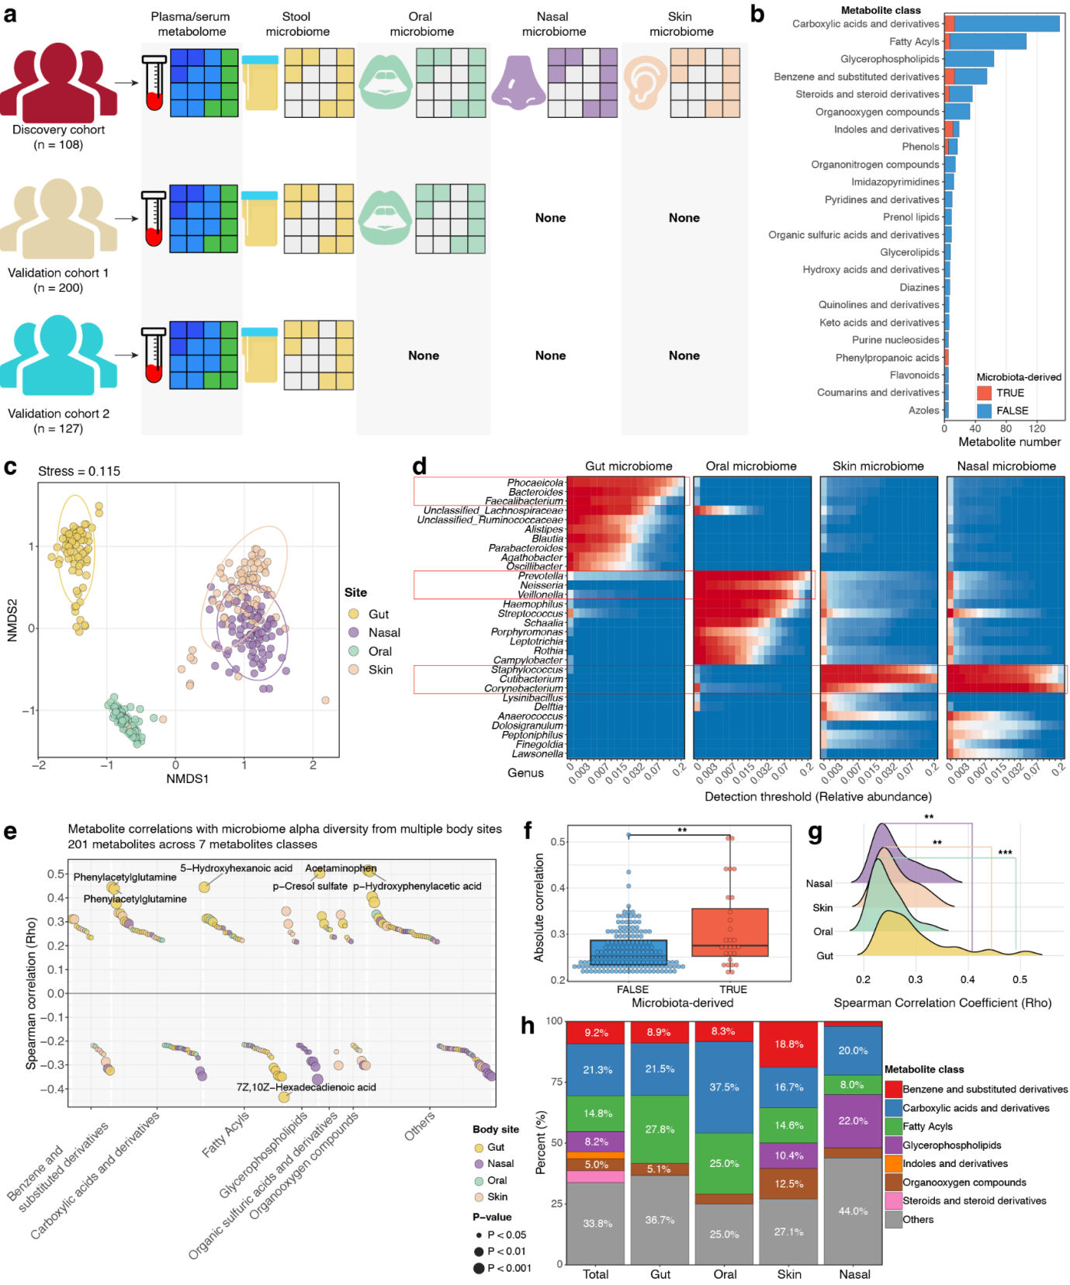Figure 1 | Associations between microbiomes from multiple body sites and plasma metabolome. a, Study design showing three cohorts in the studies: the discovery cohort (n = 108) with samples from plasma metabolome and paired microbiome data from four body sites; validation cohort 1 (n = 200) with serum metabolome, stool and oral microbiome data; and validation cohort 2 (n = 127) with plasma metabolome and stool microbiome data. b, Distribution of 814 metabolites by class in the discovery cohort, with bars colored by microbial source (microbiota-derived metabolites or not). c, NMDS plot showing distinct clustering of microbial communities by body site (stress = 0.115), with skin and nasal microbiomes exhibiting greater similarity to each other than to oral and gut microbiomes. d, Heatmap displaying the core microbiota based on different thresholds of relative abundance of genera across four body sites, showing site-specific microbial compositions. e, Spearman correlation coefficients (rho) between 201 metabolites across seven metabolite classes and microbiome alpha diversity at four body sites. f, Boxplot comparing absolute rho between microbiota-derived (n = 28) and non-microbiota-derived metabolites (n = 173) , showing significantly higher correlations for microbiota-derived metabolites (P < 0.01). g, Density plot of rho across four body sites, demonstrating significantly stronger absolute rho between metabolites and gut microbiome alpha diversity compared to other body sites. h, Distribution of metabolite classes correlated with microbiome alpha diversity across four body sites.

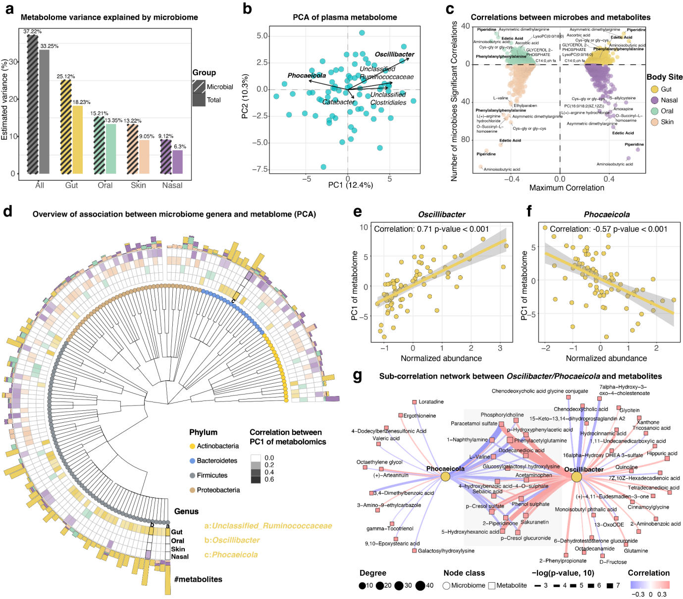Figure 2 | The gut microbiome exerts a stronger influence on the plasma metabolome compared to other body sites. a, Bar plot showing the proportion of variance of the plasma metabolome explained by microbiomes from different body sites. Both explained variances of total metabolites and microbiota-derived metabolites are shown. b, PCA score plot of the plasma metabolome (n = 108). Genus-level gut microbes significantly associated with PC1 are labeled. c, Spearman correlation analysis between plasma metabolites and microbial genera from four body sites. Each point represents a single plasma metabolite. The x-axis indicates the maximum rho with any microbial genus, while the y-axis represents the number of genera showing significant correlations with that metabolite. Microbiomes from each body site are represented in different quadrants: gut (top right), nasal (bottom right), skin (bottom left), and oral (top left). d, Circular phylogenetic tree illustrating the correlations between individual microbial genera from all four body sites and the PC1 of the plasma metabolome. Outer colored heatmaps show the strength of correlations for gut, oral, skin, and nasal microbiomes. The outermost bar plot indicates the number of metabolites significantly associated with each genus. e,f, Scatter plots showing strong and statistically significant correlations between the normalized abundance of two key gut genera, Oscillibacter (rho = 0.71, P < 0.001) and Phocaeicola (rho = –0.57, P < 0.001), and PC1 of the plasma metabolome. g, Sub-correlation network illustrating associations between the gut microbial genera Oscillibacter and Phocaeicola and their significantly correlated plasma metabolites. Nodes represent either microbial genera (yellow circle) or plasma metabolites (red square); node size is proportional to the number of edges (degree). Edge color indicates correlation direction and strength (red: positive; blue: negative), and edge width corresponds to the –log10 P values of correlations.
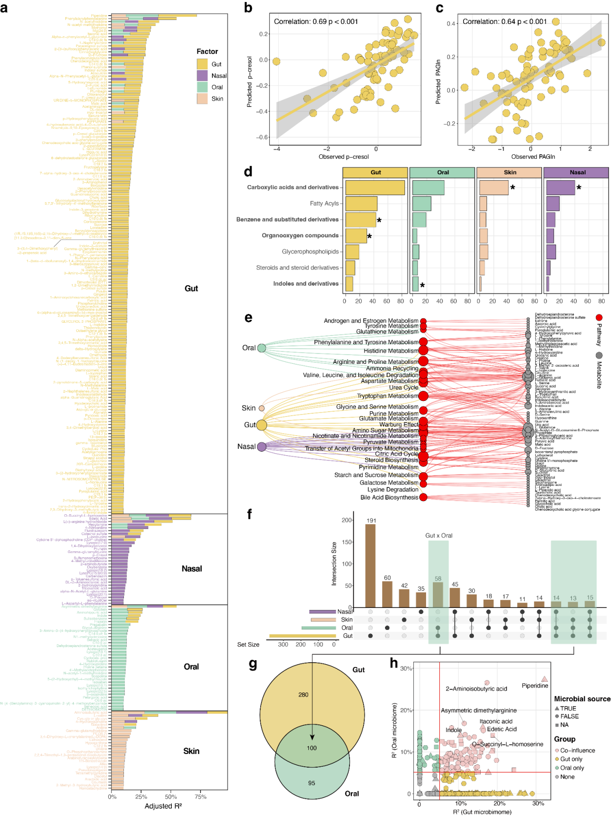
Figure 3 | Microbiome from multiple body sites cooperatively influences the human plasma metabolome. a, Bar plot showing the proportion of variance in individual circulating metabolites explained by microbiomes from four body sites using the GBDT model (n = 380). b,c, Scatter plots showing predicted versus observed abundance of two representative gut-dominated metabolites, p-cresol (b) and PAGln (c), based on gut microbiome. d, Bar plots showing the distribution of major metabolite classes influenced by microbiome from each body site. e, Bipartite network displaying metabolic pathway enrichment results of metabolites influenced by microbiome from multiple body sites. f, UpSet plot summarizing the number and overlap of metabolites explained (adjusted R² > 5%) by each body site microbiome. The largest shared influence was observed between gut and oral microbiomes, with 100 overlapping metabolites. g, Venn diagram highlighting the overlapping metabolites jointly influenced by gut and oral microbiomes. h, Scatter plot showing the distribution of metabolites jointly influenced by gut and oral microbiomes.

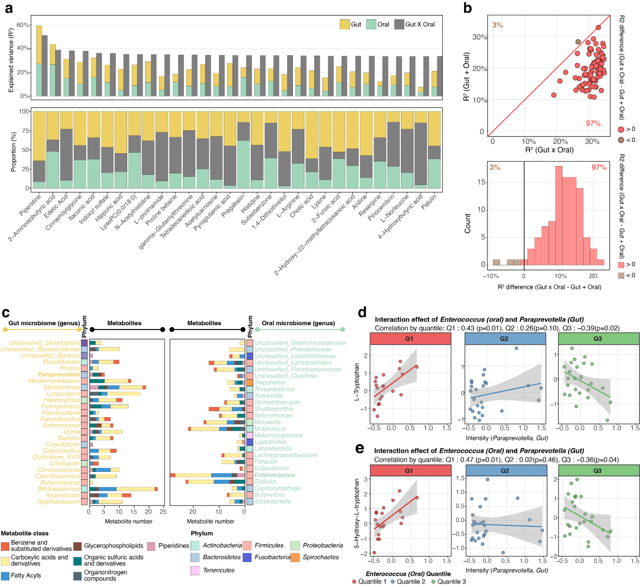
Figure 4 | Oral and gut microbiomes cooperate to influence systemic human metabolism through interactive effects. a, The top 30 metabolites with the highest variance explained by the gut and oral microbiomes. For each metabolite, the top panel shows the cumulative explained variance by the gut (green), oral (yellow), and the combined joint model (grey), which includes interaction terms between the oral and gut microbiomes. The bottom stacked bar plot illustrates the proportion of variance attributable to each component (gut-only, oral-only, and oral-gut interaction models) as estimated by the GBDT joint model. b, Scatter plot (top) and histogram (bottom) showing that for 97% of metabolites (n = 100), the variance explained by the joint oral-gut model exceeds the sum of variances explained by oral-only and gut-only models. c, Genera contributing significantly to the interaction terms between gut and oral microbiomes across circulating metabolites. Left: gut microbiome genera; right: oral microbiome genera. The bar lengths represent the number of metabolites for which each genus is involved in a significant interaction term. d, Interaction plots for the co-regulation of L-Tryptophan by Paraprevotella (gut) and Enterococcus (oral). Samples are stratified into tertiles (Q1-Q3, n = 24;25;24) based on Enterococcus abundance. e, Similar interactive pattern observed for 5-Hydroxy-L-Tryptophan, another key tryptophan-derived metabolite.

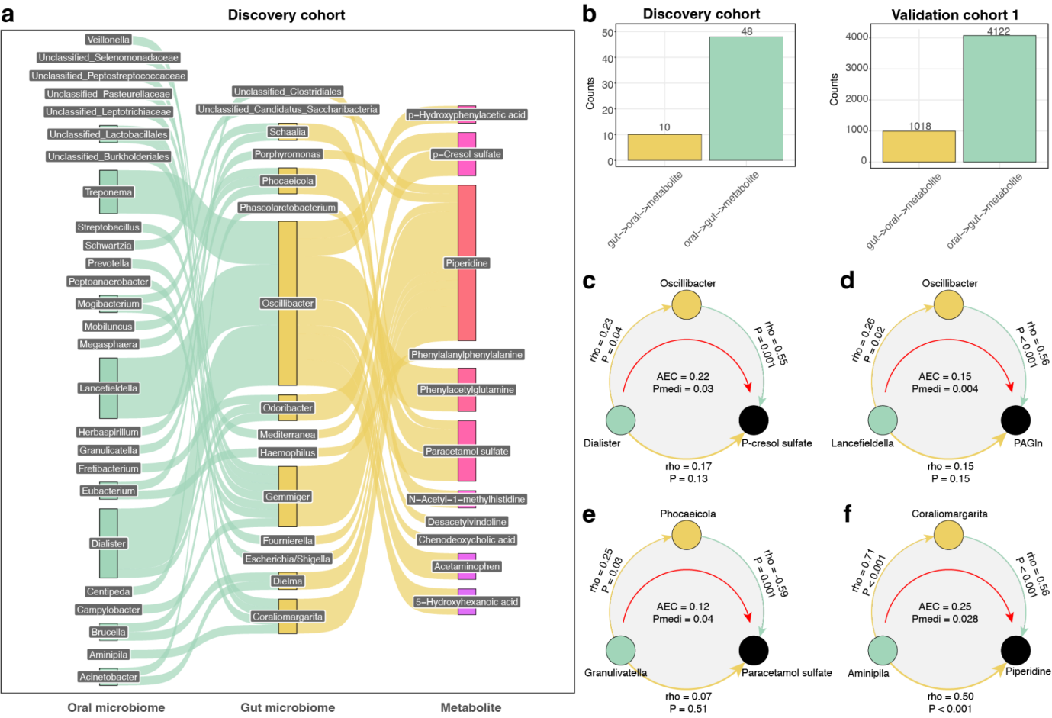
Figure 5 | The oral-gut microbiome axis facilitates coordinated metabolism of circulating metabolites through directional mediation. a, Sankey diagram illustrating significant mediation effects identified in the discovery cohort. Edges connect taxa from the oral microbiome (left, green) to gut microbial genera (middle, yellow) and ultimately to plasma metabolites (right, pink), reflecting the oral-gut-metabolite mediation pathway. b, Bar plots summarizing the number of significant mediation pathways identified in each direction, gut-oral-metabolite and oral-gut-metabolite, across the discovery cohort (left) and validation cohort 1 (right). c-f, Circular mediation diagrams showing specific examples of oral-gut microbial cooperation in influencing plasma metabolites.
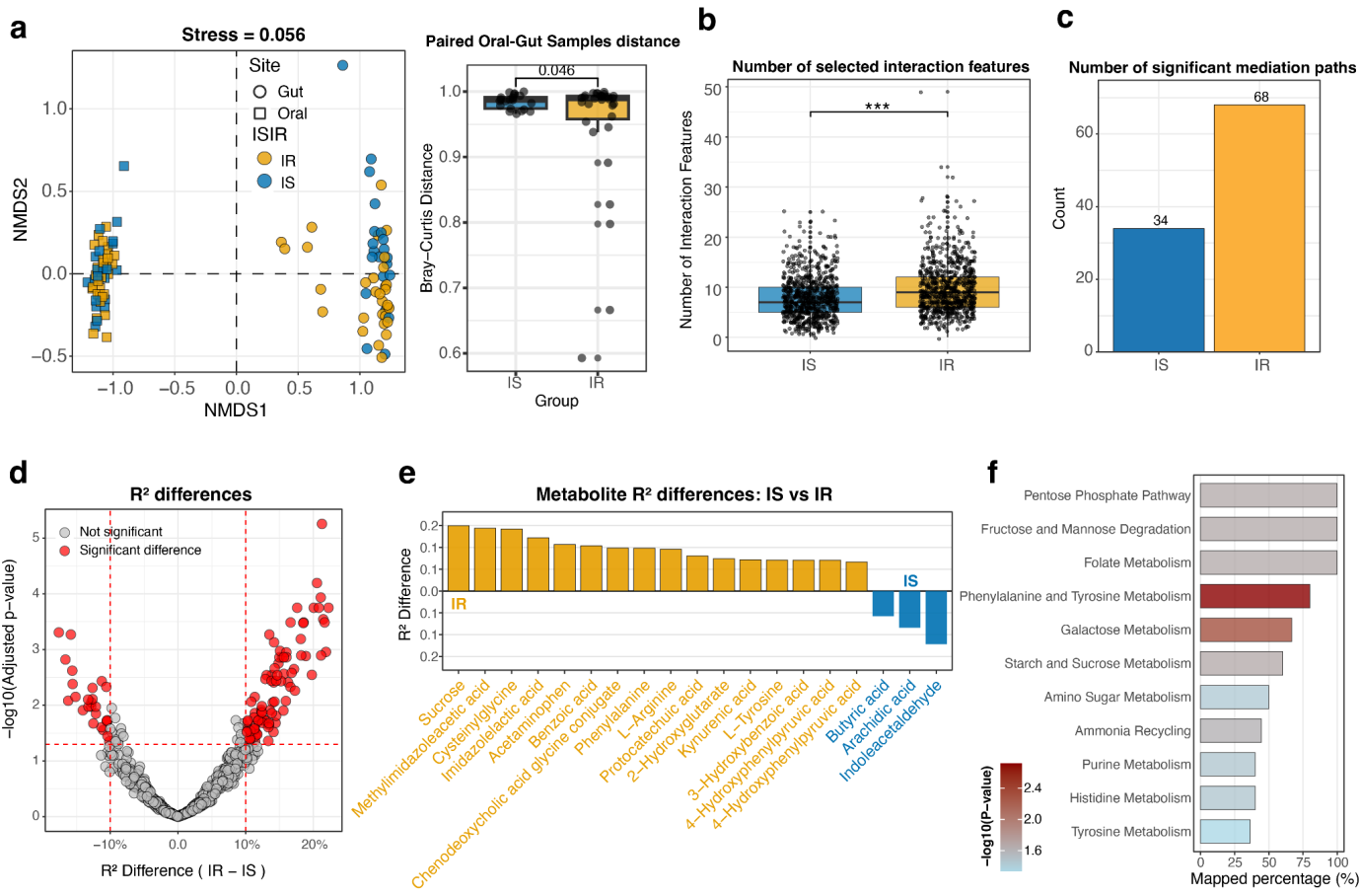
Figure 6 | Enhanced oral-gut microbiome-metabolome axis activity in IR individuals. a, NMDS ordination plot showing paired Bray-Curtis distances between oral and gut microbial communities (stress = 0.056). Points represent individual samples colored by insulin sensitivity status and shaped by body site. Box plot comparing the paired Oral-Gut Samples Bray-Curtis distances between the IS (n = 21)and IR groups (n = 31). b, Box plot comparing the number of selected interaction features between the IS and IR groups identified by the GBDT model. c, Bar chart quantifying the number of significant mediation pathways where oral microbiome influences circulating metabolites through gut microbiota as intermediary mediators in IS and IR groups. d, Volcano plot displaying R² differences between IS and IR groups for individual circulating metabolites. Red points indicate metabolites with significant differences (adjusted P < 0.05 and absolute R² difference > 0.1). e, Bar chart showing R² differences for key metabolites with the largest intergroup variations. Orange bars represent metabolites with higher R² values in the IR group; blue bars indicate higher values in the IS group. f, Pathway enrichment analysis heatmap displaying metabolic pathways significantly altered in IR individuals.

Reference

1. Integrative HMP (iHMP) Research Network Consortium. The Integrative Human Microbiome Project. Nature 569, 641–648 (2019).
2. Hou, K. et al. Microbiota in health and diseases. Signal Transduct. Target. Ther. 7, 135 (2022).
3. Visconti, A. et al. Interplay between the human gut microbiome and host metabolism. Nat. Commun. 10, 4505 (2019).
4. Boulangé, C. L., Neves, A. L., Chilloux, J., Nicholson, J. K. & Dumas, M.-E. Impact of the gut microbiota on inflammation, obesity, and metabolic disease. Genome Med. 8, 42 (2016).
5. Zhai, L. et al. Gut microbiota-derived tryptamine and phenethylamine impair insulin sensitivity in metabolic syndrome and irritable bowel syndrome. Nat. Commun. 14, 4986 (2023).
6. Takeuchi, T. et al. Gut microbial carbohydrate metabolism contributes to insulin resistance. Nature 621, 389–395 (2023).
7. Dekkers, K. F. et al. An online atlas of human plasma metabolite signatures of gut microbiome composition. Nat. Commun. 13, 5370 (2022).
8. Chen, L. et al. Influence of the microbiome, diet and genetics on inter-individual variation in the human plasma metabolome. Nat. Med. 28, 2333–2343 (2022).
9. Thangaleela, S., Sivamaruthi, B. S., Kesika, P., Bharathi, M. & Chaiyasut, C. Nasal Microbiota, Olfactory Health, Neurological Disorders and Aging-A Review. Microorganisms 10, 1405 (2022).
10. Lee, H.-J. & Kim, M. Skin Barrier Function and the Microbiome. Int. J. Mol. Sci. 23, 13071 (2022).
11. Baker, J. L., Mark Welch, J. L., Kauffman, K. M., McLean, J. S. & He, X. The oral microbiome: diversity, biogeography and human health. Nat. Rev. Microbiol. 22, 89–104 (2024).
12. Li, Y. et al. The oral microbiota and cardiometabolic health: A comprehensive review and emerging insights. Front. Immunol. 13, 1010368 (2022).
13. Liu, X. et al. Oral microbiota and respiratory diseases: advances and perspectives. Clin. Microbiol. Rev. 38, e0015024 (2025).
14. Grice, E. A. & Segre, J. A. The skin microbiome. Nat. Rev. Microbiol. 9, 244–253 (2011).
15. Dang, A. T. & Marsland, B. J. Microbes, metabolites, and the gut-lung axis. Mucosal Immunol. 12, 843–850 (2019).
16. Kunath, B. J., De Rudder, C., Laczny, C. C., Letellier, E. & Wilmes, P. The oral-gut microbiome axis in health and disease. Nat. Rev. Microbiol. 22, 791–805 (2024).
17. Xu, Q. et al. The oral-gut microbiota axis: a link in cardiometabolic diseases. NPJ Biofilms Microbiomes 11, 11 (2025).
18. Barbour, A., Elebyary, O., Fine, N., Oveisi, M. & Glogauer, M. Metabolites of the oral microbiome: important mediators of multikingdom interactions. FEMS Microbiol. Rev. 46, fuab039 (2022).
19. Malan-Müller, S. et al. Probing the oral-brain connection: oral microbiome patterns in a large community cohort with anxiety, depression, and trauma symptoms, and periodontal outcomes. Transl. Psychiatry 14, 419 (2024).
20. Liao, C. et al. Oral bacteria relative abundance in faeces increases due to gut microbiota depletion and is linked with patient outcomes. Nat. Microbiol. 9, 1555–1565 (2024).
21. Bao, J. et al. Periodontitis may induce gut microbiota dysbiosis via salivary microbiota. Int. J. Oral Sci. 14, 32 (2022).
22. Shen, X. et al. Nonlinear dynamics of multi-omics profiles during human aging. Nat. Aging 4, 1619–1634 (2024).
23. Zhou, W. et al. Longitudinal multi-omics of host-microbe dynamics in prediabetes. Nature 569, 663–671 (2019).
24. Zhou, X. et al. Longitudinal profiling of the microbiome at four body sites reveals core stability and individualized dynamics during health and disease. Cell Host Microbe 32, 506-526.e9 (2024).
25. Shoer, S. et al. Impact of dietary interventions on pre-diabetic oral and gut microbiome, metabolites and cytokines. Nat. Commun. 14, 5384 (2023).
26. Wu, X. et al. A legume-enriched diet improves metabolic health in prediabetes mediated through gut microbiome: a randomized controlled trial. Nat. Commun. 16, 942 (2025).
27. Krautkramer, K. A., Fan, J. & Bäckhed, F. Gut microbial metabolites as multi-kingdom intermediates. Nat. Rev. Microbiol. 19, 77–94 (2021).
28. Agus, A., Clément, K. & Sokol, H. Gut microbiota-derived metabolites as central regulators in metabolic disorders. Gut 70, 1174–1182 (2021).
29. Chu, D. M. et al. Maturation of the infant microbiome community structure and function across multiple body sites and in relation to mode of delivery. Nat. Med. 23, 314–326 (2017).
30. Baede, V. O. et al. Nasal microbiome disruption and recovery after mupirocin treatment in Staphylococcus aureus carriers and noncarriers. Sci. Rep. 12, 19738 (2022).
31. Seo, J. Y. et al. Longitudinal study of the interplay between the skin barrier and facial microbiome over 1 year. Front. Microbiol. 14, 1298632 (2023).
32. Qu, Q. et al. Population-level gut microbiome and its associations with environmental factors and metabolic disorders in Southwest China. NPJ Biofilms Microbiomes 11, 24 (2025).
33. Sun, W. et al. A population-scale analysis of 36 gut microbiome studies reveals universal species signatures for common diseases. NPJ Biofilms Microbiomes 10, 96 (2024).
34. Hammad, M. I., Conrads, G. & Abdelbary, M. M. H. Isolation, identification, and significance of salivary Veillonella spp., Prevotella spp., and Prevotella salivae in patients with inflammatory bowel disease. Front. Cell. Infect. Microbiol. 13, 1278582 (2023).
35. Caselli, E. et al. Defining the oral microbiome by whole-genome sequencing and resistome analysis: the complexity of the healthy picture. BMC Microbiol. 20, 120 (2020).
36. Könönen, E. & Gursoy, U. K. Oral Prevotella Species and Their Connection to Events of Clinical Relevance in Gastrointestinal and Respiratory Tracts. Front. Microbiol. 12, 798763 (2021).
37. Human Microbiome Project Consortium. Structure, function and diversity of the healthy human microbiome. Nature 486, 207–214 (2012).
38. Wilmanski, T. et al. Blood metabolome predicts gut microbiome α-diversity in humans. Nat. Biotechnol. 37, 1217–1228 (2019).
39. Zhu, Y. et al. Two distinct gut microbial pathways contribute to meta-organismal production of phenylacetylglutamine with links to cardiovascular disease. Cell Host Microbe 31, 18-32.e9 (2023).
40. van Duynhoven, J. et al. Metabolic fate of polyphenols in the human superorganism. Proc. Natl. Acad. Sci. U. S. A. 108 Suppl 1, 4531–4538 (2011).
41. Pascal Andreu, V. et al. gutSMASH predicts specialized primary metabolic pathways from the human gut microbiota. Nat. Biotechnol. 41, 1416–1423 (2023).
42. Wang, P. et al. Gut microbiota-derived 4-hydroxyphenylacetic acid from resveratrol supplementation prevents obesity through SIRT1 signaling activation. Gut Microbes 17, 2446391 (2025).
43. Malard, L. A. & Guisan, A. Into the microbial niche. Trends Ecol. Evol. 38, 936–945 (2023).
44. Bar, N. et al. A reference map of potential determinants for the human serum metabolome. Nature 588, 135–140 (2020).
45. Dodd, D. et al. A gut bacterial pathway metabolizes aromatic amino acids into nine circulating metabolites. Nature 551, 648–652 (2017).
46. Thaiss, C. A., Zmora, N., Levy, M. & Elinav, E. The microbiome and innate immunity. Nature 535, 65–74 (2016).
47. Schirmer, M. et al. Linking the Human Gut Microbiome to Inflammatory Cytokine Production Capacity. Cell 167, 1125-1136.e8 (2016).
48. Li, C. et al. Gut microbiome and metabolome profiling in Framingham heart study reveals cholesterol-metabolizing bacteria. Cell 187, 1834-1852.e19 (2024).
49. Diener, C. et al. Genome-microbiome interplay provides insight into the determinants of the human blood metabolome. Nat. Metab. 4, 1560–1572 (2022).
50. Liu, R. et al. Gut microbiome and serum metabolome alterations in obesity and after weight-loss intervention. Nat. Med. 23, 859–868 (2017).
51. Codipilly, D. & Kleinberg, I. Generation of indole/skatole during malodor formation in the salivary sediment model system and initial examination of the oral bacteria involved. J. Breath Res. 2, 017017 (2008).
52. Roager, H. M. & Licht, T. R. Microbial tryptophan catabolites in health and disease. Nat. Commun. 9, 3294 (2018).
53. Wang, G. et al. Microbiota-derived indoles alleviate intestinal inflammation and modulate microbiome by microbial cross-feeding. Microbiome 12, 59 (2024).
54. Wu, H. et al. Microbiome-metabolome dynamics associated with impaired glucose control and responses to lifestyle changes. Nat. Med. (2025) doi:10.1038/s41591-025-03642-6.
55. Liu, Y., Hou, Y., Wang, G., Zheng, X. & Hao, H. Gut Microbial Metabolites of Aromatic Amino Acids as Signals in Host-Microbe Interplay. Trends Endocrinol. Metab. TEM 31, 818–834 (2020).
56. Jiang, Z. et al. Human gut microbial aromatic amino acid and related metabolites prevent obesity through intestinal immune control. Nat. Metab. 7, 808–822 (2025).
57. Ding, J. et al. Regulation of tryptophan-indole metabolic pathway in Porphyromonas gingivalis virulence and microbiota dysbiosis in periodontitis. NPJ Biofilms Microbiomes 11, 37 (2025).
58. Gao, K., Mu, C.-L., Farzi, A. & Zhu, W.-Y. Tryptophan Metabolism: A Link Between the Gut Microbiota and Brain. Adv. Nutr. Bethesda Md 11, 709–723 (2020).
59. Pacheco-Yanes, J., Reynolds, E., Li, J. & Mariño, E. Microbiome-targeted interventions for the control of oral-gut dysbiosis and chronic systemic inflammation. Trends Mol. Med. 29, 912–925 (2023).
60. Yang, Z., Du, C., Chang, Z., Yang, Y. & Hu, L. Role of oral and gut microbiomes in enterosalivary nitrate metabolism and their effects on systemic disease. Front. Cell. Infect. Microbiol. 15, 1612223 (2025).
61. Leonov, G. E., Varaeva, Y. R., Livantsova, E. N. & Starodubova, A. V. The Complicated Relationship of Short-Chain Fatty Acids and Oral Microbiome: A Narrative Review. Biomedicines 11, 2749 (2023).
62. Brown, J. et al. Microbiota-mediated skewing of tryptophan catabolism modulates CD4+ T cells in lupus-prone mice. iScience 25, 104241 (2022).
63. Kaur, H., Bose, C. & Mande, S. S. Tryptophan Metabolism by Gut Microbiome and Gut-Brain-Axis: An in silico Analysis. Front. Neurosci. 13, 1365 (2019).
64. Kilian, M. et al. The oral microbiome - an update for oral healthcare professionals. Br. Dent. J. 221, 657–666 (2016).
65. Guo, X.-J. et al. Distribution characteristics of oral microbiota and its relationship with intestinal microbiota in patients with type 2 diabetes mellitus. Front. Endocrinol. 14, 1119201 (2023).
66. Li, Y. et al. Oral-gut microbial transmission promotes diabetic coronary heart disease. Cardiovasc. Diabetol. 23, 123 (2024).
67. Barutta, F., Bellini, S., Durazzo, M. & Gruden, G. Novel Insight into the Mechanisms of the Bidirectional Relationship between Diabetes and Periodontitis. Biomedicines 10, 178 (2022).
68. Mei, Z. et al. Strain-specific gut microbial signatures in type 2 diabetes identified in a cross-cohort analysis of 8,117 metagenomes. Nat. Med. 30, 2265–2276 (2024).
69. Zakaria, N. F., Hamid, M. & Khayat, M. E. Amino Acid-Induced Impairment of Insulin Signaling and Involvement of G-Protein Coupling Receptor. Nutrients 13, 2229 (2021).
70. Wang, J. et al. Histidine-derived carbon dots for redox modulation and gut microbiota regulation in inflammatory bowel disease therapy. Chem. Eng. J. 499, 156389 (2024).
71. Hirasawa, N. Expression of Histidine Decarboxylase and Its Roles in Inflammation. Int. J. Mol. Sci. 20, 376 (2019).
72. Liu, X. et al. Mendelian randomization analyses support causal relationships between blood metabolites and the gut microbiome. Nat. Genet. 54, 52–61 (2022).
73. Zhou, Y. et al. The role of the indoles in microbiota-gut-brain axis and potential therapeutic targets: A focus on human neurological and neuropsychiatric diseases. Neuropharmacology 239, 109690 (2023).
74. Korac, B., Kalezic, A., Pekovic-Vaughan, V., Korac, A. & Jankovic, A. Redox changes in obesity, metabolic syndrome, and diabetes. Redox Biol. 42, 101887 (2021).
75. Teeuw, W. J., Gerdes, V. E. A. & Loos, B. G. Effect of periodontal treatment on glycemic control of diabetic patients: a systematic review and meta-analysis. Diabetes Care 33, 421–427 (2010).
76. Wishart, D. S. et al. HMDB 5.0: the Human Metabolome Database for 2022. Nucleic Acids Res. 50, D622–D631 (2022).
77. Shen, X. & Snyder, M. P. microbiomedataset: A tidyverse-style framework for organizing and processing microbiome data. 2023.09.17.558096 Preprint at https://doi.org/10.1101/2023.09.17.558096 (2023).
78. Shen, X. et al. TidyMass an object-oriented reproducible analysis framework for LC-MS data. Nat. Commun. 13, 4365 (2022).
79. Shen, X., Wang, C. & Snyder, M. P. massDatabase: utilities for the operation of the public compound and pathway database. Bioinforma. Oxf. Engl. 38, 4650–4651 (2022).

